# AI LAB ASSIGNMENT 4.3

# Hall ticket : 2403A51310

# Task Description#1

* Zero-shot: Prompt AI to write a function that checks whether a given year is a leap year.;

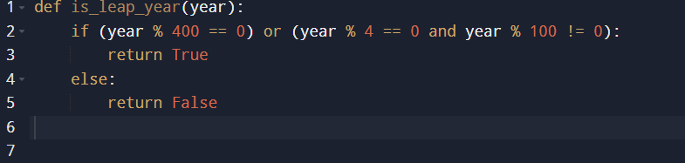

# Observation:

In this task, the AI was able to generate a leap year function without any examples. The code worked correctly and followed the basic leap year rules. However, the output was simple and did not include much explanation or handling of extra cases, which shows that zero-shot works but may lack depth.

# Task Description#2

One-shot: Give one input-output example to guide AI in writing a function that converts centimeters to inches.

# Observation:

With one example provided, the AI clearly understood the requirement for conversion. The function produced accurate results and matched the given input-output format. This shows that one-shot prompting improves clarity and ensures the AI gives more focused solutions compared to zero-shot.

# Task Description#3

* Few-shot: Provide 2–3 examples to generate a function that formats full names as “Last, First”.

# Observation:

By giving 2–3 examples of formatting names, the AI produced a well-structured function that correctly converted names into the “Last, First” format. The multiple examples helped the AI learn the exact pattern and apply it consistently, proving that few-shot prompting gives more reliable

# Task Description#4

* Compare zero-shot and few-shot prompts for writing a function that counts the number of vowels in a string.

# Zero-Shot:

Write a Python function that counts the number of vowels in a string

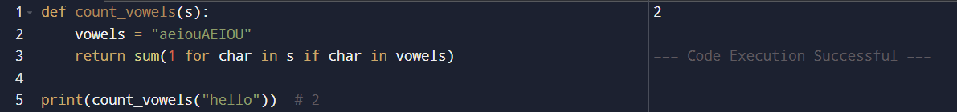

# Few-shot:

Write a Python function that counts the number of vowels in a string.

# Observation:

In the comparison task, the zero-shot version gave a working solution but without any guided examples. The few-shot version, on the other hand, matched the examples more closely and produced more accurate outputs. This shows that while zero-shot can solve simple tasks, few-shot improves performance by reducing ambiguity.

# Task Description#5

* Use few-shot prompting to generate a function that reads a .txt file and returns the number of lines.

# 

# Observation:

With examples provided, the AI generated a correct file-reading function that could handle cases like empty files and multi-line files. The few-shot prompting guided the AI to focus on the logic needed for file processing, leading to a more complete and effective solution.